Push failed and by mistake done the pull immediately which has not merged automatically and caused deleting previously added files even from local repository. Then check log for head and take checkout and commit it again.

Eg; mistake and correction:

If initial project in local system not having any repository in git then initialize git first. The push it.

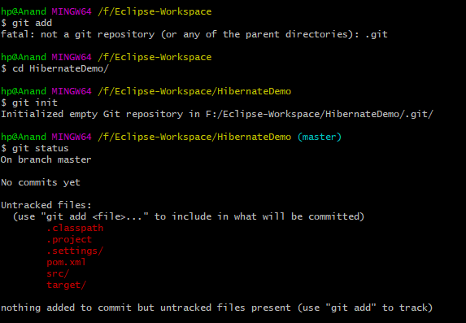

1. 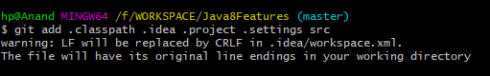

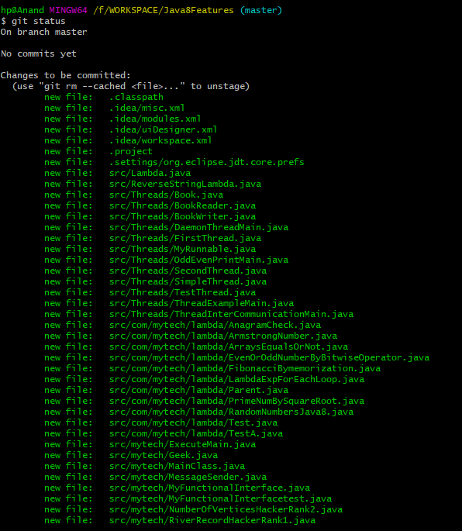

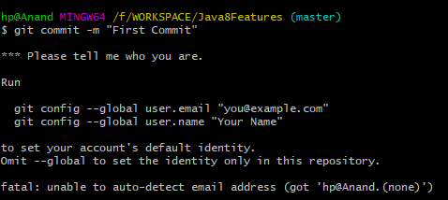

This is because committing files to git at first time.

So I have added my user name and email to git then committed files.

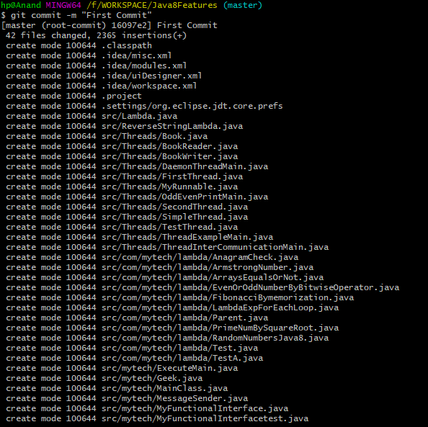

In below its not able to push to remote (git) repository.

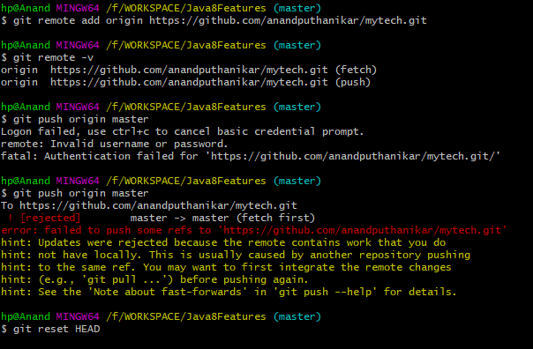

Then I tried to reset my Head for my last commits but status won’t show the files in local repository. So I pull the files from repo. 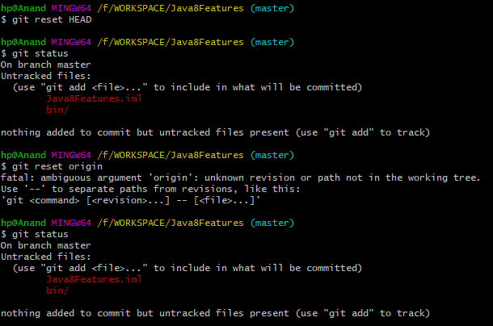

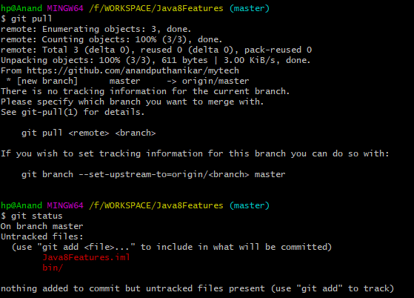

After pull also did not get files back to local repo, which are even not available at git repository.

All the files which are added before my pull were deleted because the index has been removed from git commit .

**SOLUTION:**

1. Here in list the initial commit is which had all files which have been deleted . We can see all deleted files by “git ls-file –d” 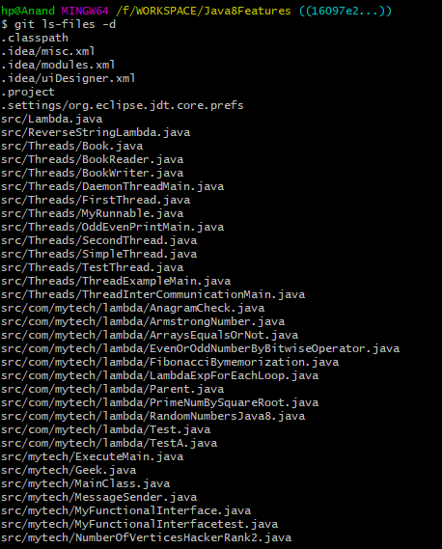
2. Checked log for my commit message. By “git reflog” 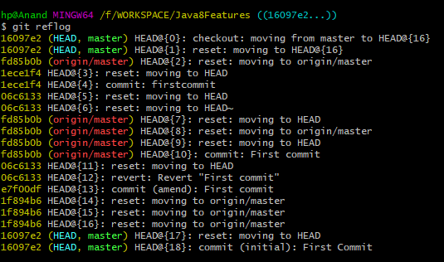
3. “First Commit” is my initial commit message which had all files & directory. 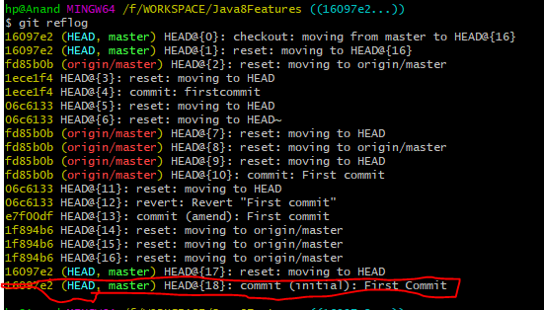
4. Checkout to git to this initial HEAD. From reflog take header index “ git checkout HEAD@{18}”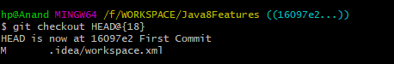
5. Then amend the commit – if no changes and require to push this commit to repository. 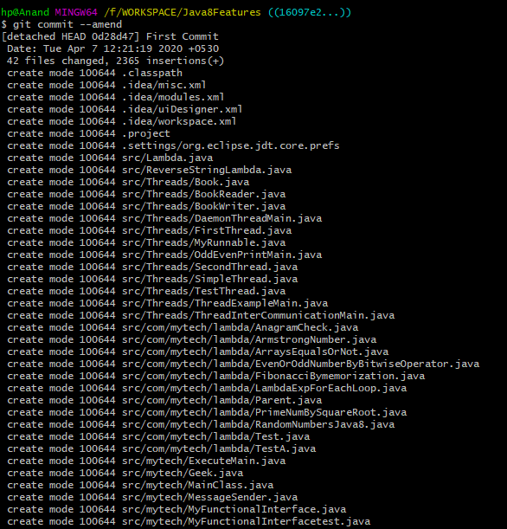
6. Then push 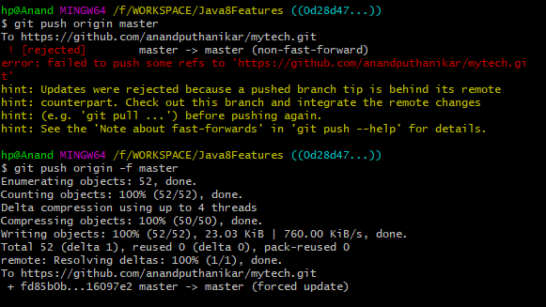

Here it is failed because non-fast-forward. Hence I forced to push files to master.

Which are successfully updated to git.

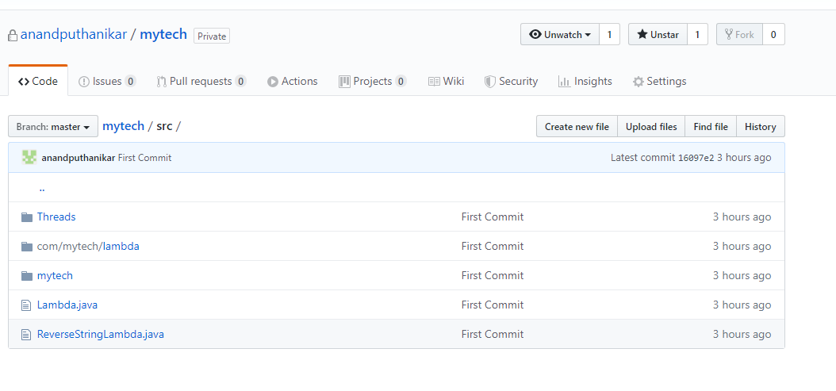

Git pull at first time require some config if need to set default stream to project repository  
